Project Design Phase-II
Technology Stack (Architecture & Stack)

Date | 31 January 3035
Team ID | LTVIP2026TMIDS80646
Project Name | Dog Breed Identification using Transfer Learning (VGG19) with Flask Deployment
Maximum Marks | 4 Marks

Technical Architecture:
Project: Dog Breed Identification using Transfer Learning (VGG19) with Flask Deployment
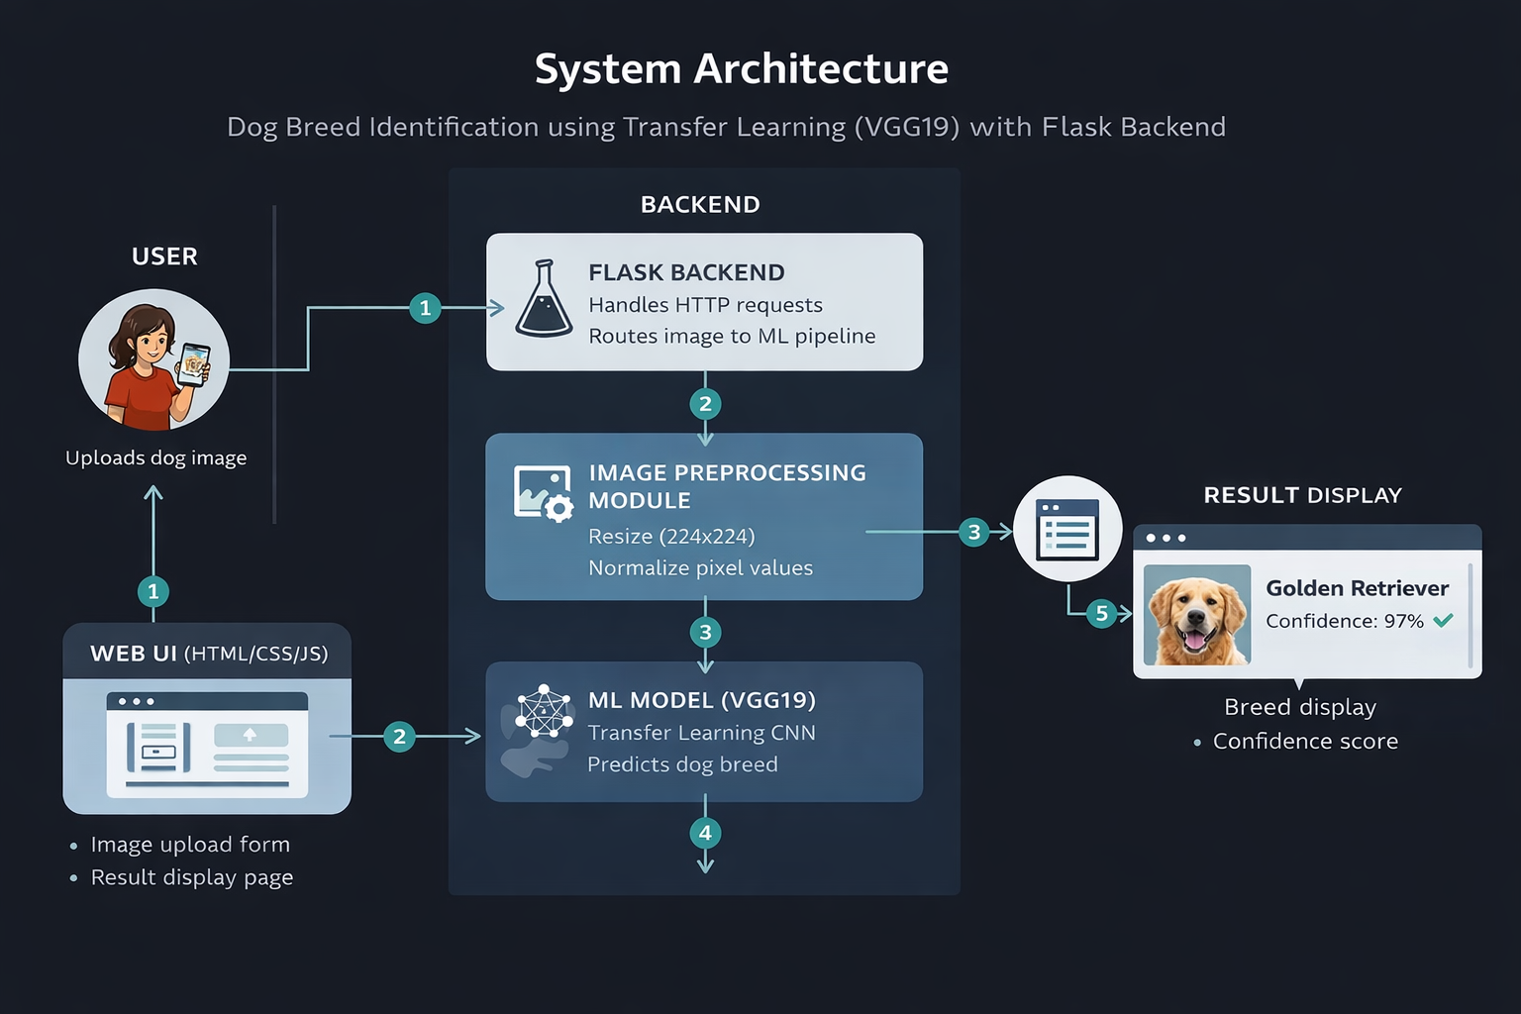
Table-1 : Components & Technologies:

S.No | Component | Description | Technology
1 | User Interface | Web interface for image upload and viewing predictions | HTML, CSS, JavaScript
2 | Application Logic-1 | Handles routing, file upload, request processing | Python (Flask)
3 | Application Logic-2 | Image preprocessing & inference pipeline | TensorFlow / Keras
4 | Application Logic-3 | Business logic for prediction formatting & confidence display | Python
5 | Database | Optional metadata storage (logs, results) | Not used / SQLite (optional)
6 | Cloud Database | Cloud-based storage (future scope) | Not used (Future: Firebase / MongoDB Atlas)
7 | File Storage | Stores uploaded images and model files | Local File System
8 | External API-1 | Dataset source (for training phase) | Kaggle Dataset
9 | External API-2 | Optional future API integration | Not used
10 | Machine Learning Model | Dog breed classification using transfer learning | VGG19 (Pre-trained on ImageNet)
11 | Infrastructure (Server) | Application deployment environment | Localhost (Flask on Local System)

Table-2: Application Characteristics:

S.No | Characteristics | Description | Technology Used
1 | Open-Source Frameworks | Frameworks and libraries used in development | Flask, TensorFlow, Keras, NumPy
2 | Security Implementations | Basic security for file upload and server access | Flask validations, Input sanitization
3 | Scalable Architecture | 3-tier architecture (UI, Backend, ML Model). Scalable with cloud deployment | Flask API + Modular ML Pipeline
4 | Availability | Application available locally; can be deployed on cloud for high availability | Localhost (Future: Render/Heroku)
5 | Performance | Model loaded once at server startup; optimized inference pipeline | Preloaded model, Efficient CNN

